Virtual Field Trip: Exploring Earth’s Mantle

Physical Geology - Spring 2025

Name:

myUH ID number:

Professor’s Name:

Class Time:

# Academic Honesty (Acknowledgement Required)

The mantle assignment is to be completed by yourself; you should not work with a partner or group. Do not search for answers on the internet because 1) it is cheating; 2) answers that are posted are incorrect, and we’ll know where you got them from, and; 3) the questions change every semester. If you are unfamiliar with a word or geologic concept, it is okay to look it up online to find the correct spelling and definition. If you find yourself needing help, physical geology teaching assistants staff the Geoscience Learning Center in Fleming 136.

By submitting this work, I, Type Your Name Here attest that I have not violated the UH Academic Honesty code. I completed this assignment by myself and did not copy any portion of my answers from another student, website, or any other source, including AI.

If you submit this material to an online learning platform such as Chegg, Course Hero, or any other education technology website, you violate the UH academic honesty policy and the Creative Commons license.

# Instructions

Complete the assignment in this document.

## Written Answers

All answers should be written in complete sentences and typed in the supplied boxes. Your responses will appear in a **red-colored font like this**, do not change this. Any answers not written in complete sentences will be marked as incorrect and will not receive credit. Each stop has several questions, and you’ll be able to choose which ones to answer.

## Assignment Submission

All virtual field trips are due by Sunday, April 27. Save your completed Word document as “yourlastname_firstname_MantleVFT”. Failure to use this naming convention may result in you not receiving credit. The file size must be less than 10 MB. If you need to [reduce your file size](https://support.microsoft.com/en-us/office/reduce-the-file-size-of-your-word-documents-6c5a1186-6353-453d-bb22-e9322c2cfbab), make sure images/annotations are still legible. Submit your completed document using the following [form](https://forms.office.com/r/ev94un4pJe), you must be logged into your @cougarnet.uh.edu Microsoft account. Only Microsoft Word and PDF formats are accepted.

**Due Date:** Sunday, April 27

**Submission link:** <https://forms.office.com/r/ev94un4pJe> (make a separate submission for each VFT you complete)

Teaching Assistants will begin grading submissions after the deadline. After your work is graded, you will receive a confirmation email from a TA. Submissions are graded as pass/fail. If your assignment requires resubmission because of too many incorrect questions, missing answers, or incomplete sentences, you will have 48 hours to do so.

# Preface

Geological field trips are one of the primary ways that geologists can learn about the natural history of the Earth. Typical tools for traditional geological field trips include rock hammers, hand lenses, and map boards. However, these classic geologic field trips are only possible if the rocks of interest are exposed on the Earth’s surface. Most of Earth’s geology is deep beneath our feet, in the Earth’s interior. In this assignment, we will explore Earth’s mantle. The mantle was once considered a relatively featureless realm between the crust and core. However, current ideas (see Fig. 1 below) suggest the mantle contains hot, buoyant ‘plumes’ of abnormally hot rock that rise under ‘hotspot chains’ such as Hawaii. Under subduction zones, ancient oceanic crust is inserted and recycled into the mantle, sinking and buckling under its own weight to the core-mantle boundary.

Geophysical techniques such as seismic tomography provide geologists with a window to peer into the 3D structure of the mantle to study present tectonic processes and the geologic past. This exercise will introduce students to mantle tomography, which is providing increasingly clearer images of Earth’s interior that are very similar to CT scans utilized by medical doctors.

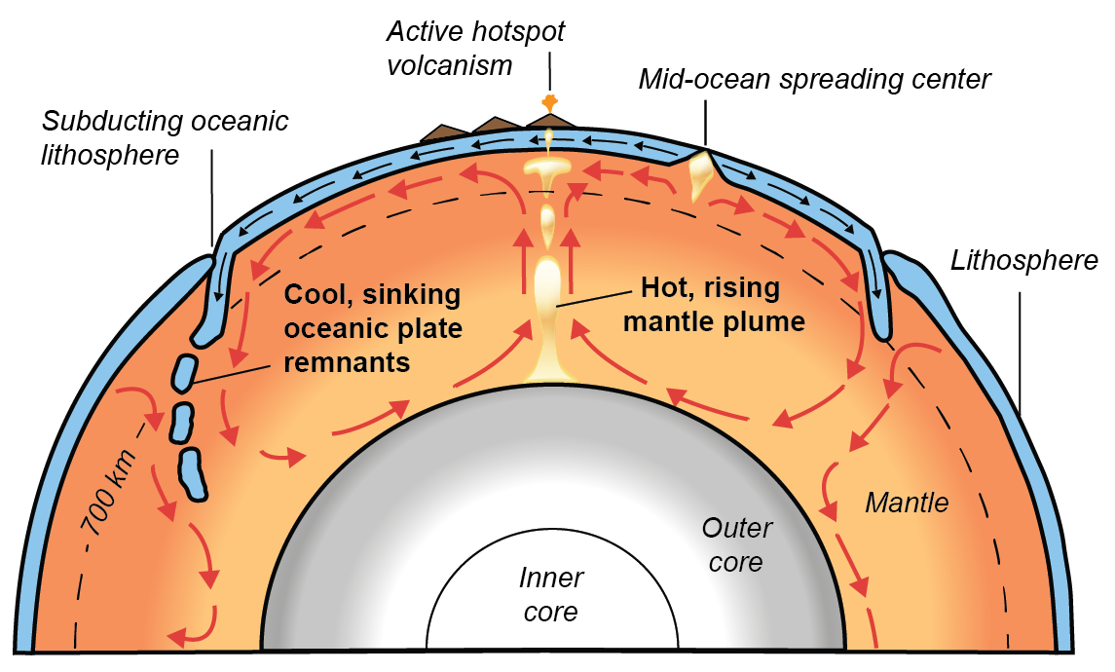

Figure - Earth’s mantle showing possible mantle flows (red arrows). Whole-mantle convection is driven by the sinking of cooler, subducted oceanic lithosphere, and the rising of hot, mantle plumes from the core-mantle boundary (re-drawn from USGS).

## Aims

The purpose of this assignment is to make observations of the Earth’s mantle from seismic tomography. Our window into the mantle will be provided by the Hades Underworld Explorer (<http://www.atlas-of-the-underworld.org/hades-underworld-explorer/>), which was generously built by researcher Dr.Douwe van Hinsbergen of Utrecht University, Netherlands.

## Getting Started

Before we begin, let us first review two important terms: cross-sections, and seismic tomography. In this assignment, we look at ***cross-sections***. A cross-section is a view exposed from making a straight cut through an object. For example, the Figure 2 photo below shows a cross-section through an apple. In this exercise, we will look at cross-sections of the Earth. Have another look at Figure 1. Can you visualize how Figure 1 shows a straight cut through a spherical Earth?

|  |  |
| --- | --- |
| Figure - Cross-section through an apple shown on the right. (Source: Wikipedia https://en.wikipedia.org/wiki/Australian_cuisine) | A whole green apple and a green apple cut in half. |

Obviously, we cannot slice across the entire Earth like an apple. However, seismologists have developed ***seismic tomography*** to image the Earth’s interior. Seismic tomography uses seismic waves from earthquakes to create computer-generated Earth cross-sections. The cross-sections are colored by the variations in earthquake wave speeds, which can vary by several percent within Earth. Although research continues on specific reasons for these wave speed variations, most scientists agree that thermal differences (i.e. hotter or cooler regions) within Earth play the most important role. Hence, seismic tomography can be understood as a thermal camera image of the Earth. Figure 3 below shows a thermal camera image of two feet that reveal higher temperatures in one foot (left side of image).

|  |  |
| --- | --- |
| Figure - Thermal camera imaging of two feet. (Source: https://reductionrevolution.com.au/blogs/news-reviews/thermal-camera-infrared-scanner-uses) | Infrared camera circulation issues in legs |

# Part 1: A deep dive into the mantle under South America

We will now look at seismic tomography of the Earth’s mantle using Hades Underworld Explorer. This tool provides a web interface in which you can specify the start and end points of a geologic cross-section through the Earth (from the Earth surface to the core-mantle boundary at 2890 km depths). Mantle tomography data is then displayed on the specified cross-section slice. To get started:

1. In a web browser, load the Hades Underworld Explorer (<http://www.atlas-of-the-underworld.org/hades-underworld-explorer/>). **Note: Do not use a Firefox browser.**
2. Navigate to the top right corner of the map window and click on the button entitled “Settings (expand)”.
3. Check these two boxes: “Show high contrast image” and “Show plate boundaries”. This will make mantle features clearer. The plate boundaries will help you to better locate your cross-sections.

On the map interface, navigate Google Maps to drag and move the “L” marker off the west coast of southern Mexico and the “R” marker off the eastern Caribbean. Note: “L” marks the left edge of the section, and “R” marks the right edge. An example is shown below in Figure 4.

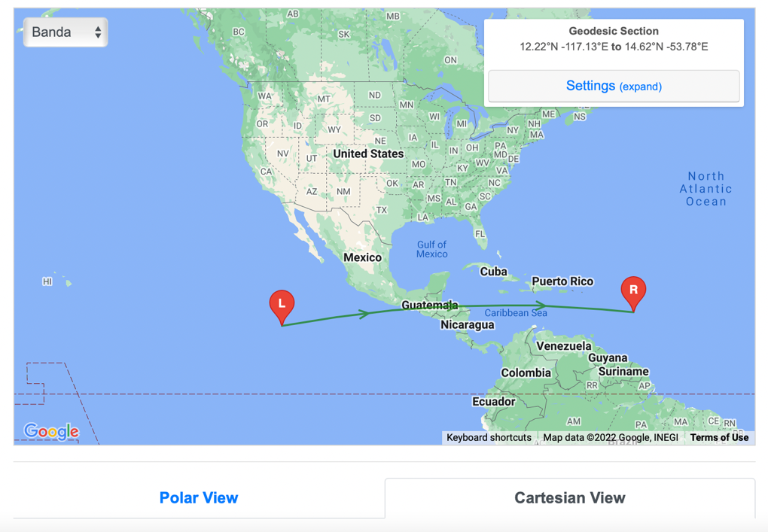

Figure 4 - Example from the Atlas of the Underworld Google Maps interface. The blue arrow shows the ‘Polar View’ and ‘Cartesian View’ tabs referred to in Question 3.

Examine the generated cross-section, then answer the following questions:

1. Why is the top of the cross-section curved?

1. What does the upper surface (the top of the cross-section) of the cross-section represent (i.e., what part of Earth)?

1. Click on the ‘Cartesian View’ and ‘Polar View’ tabs under the Google Map interface (e.g. blue arrow in Fig. 4). Compare the difference in the two views. The ‘Polar View’ shows the image in a more realistic shape based on a spherical Earth. The ‘Cartesian View’ provides a larger view in a flattened, box-like Earth. Having both views is helpful for geoscientists. Also, note the two white lines for depth reference. The upper line denotes 410 kilometers depth and the lower line denotes 660 kilometers depth. At these depths, it is thought that grains of the mineral olivine rearrange to form a denser crystal structure (i.e. mineral ‘phase changes’).
   1. What is the overall length of your cross-section at the Earth’s surface? Note that Cartesian View offers a length scale bar at the bottom that will help with this question.

**km**

* 1. What Earth boundary layer is represented at the lower surface of the cross-section at 2890 km depth? Hint: think of Earth layers such as the crust, mantle, core, etc.

# Part 2: Convergent plate boundaries

As previously mentioned, seismic tomography shows regions of the Earth interior where seismic waves travel more slowly or more rapidly than expected. The tomographic color scale shows:

* warmer colors (red, orange) in areas where seismic waves have traveled slower than expected. Often these are interpreted as ‘hotter’ temperature areas.
* cooler colors (blue) in areas where seismic waves have traveled faster than expected. Often these areas are interpreted as ‘cooler’ temperature areas.

1. Your cross-section cuts across a subduction plate boundary along the western coast of Central America. Here, the Cocos Ocean plate is subducted below Central America. Describe in your own words what you observe from tomography of the Earth’s mantle under Central America. Which features (i.e., hot/ cold material, geometries of the anomalies, etc.) from Figure 1 can you identify in your tomographic cross-section? Explain.

1. The image below in Figure 5 shows a view of the mantle tomography under Central America. It is fine if your view appears slightly different to Figure 5. Based on a recent study, the brighter blue ‘fast velocity’ area traces possible colder-temperature remnants of subducted tectonic plates in the mantle. This feature has been called the ‘Cocos slab’.

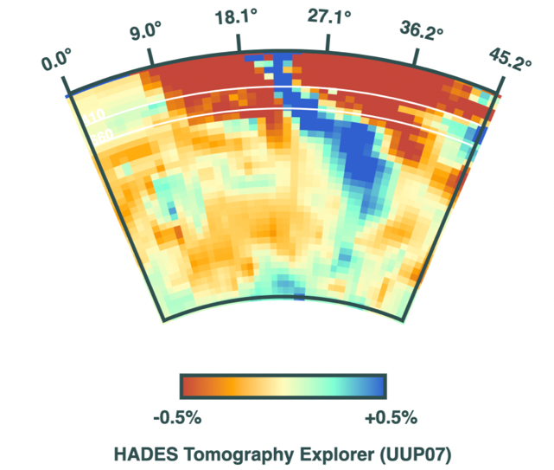

Base of subducted Cocos slab

Figure - Example cross-section of tomography across Central America. The base of the subducted Coco slab is at the bottom of the brighter blue ‘fast velocity’ anomaly.

1. Example cross-section of tomography across Central America. The base of the subducted Coco slab is at the bottom of the brighter blue ‘fast velocity’ anomaly.
   1. From your cross-section, determine the approximate depth to the base of the subducted ‘Cocos slab’ in the mantle. The black arrow in Figure 5 above shows an example of the base of the Cocos slab. Note: the ‘Cartesian View’ has a depth scale that is helpful to answer this question.

**km depth**

* 1. Let us think more about how deep the Cocos slab extends into the mantle in terms of a driving 'road trip'. Which road trip below would be most similar to the length of your calculated subducted Nazca tectonic plate length? Highlight your answer.

1. Houston to Anchorage, Alaska, 6600 km away (68 hrs driving)
2. Houston to San Francisco, 3100 km away (28 hrs driving)
3. Houston to Miami,1900 km away (17 hrs driving)
4. Houston to San Antonio, 315 km away (3 hours driving)

# Part 3: Mantle Plumes and Hot Spots

Move the “L” marker to the Pacific Ocean off the western coast of the Big Island in Hawaii. Then move the “R” marker a similar distance off the eastern coast of Hawaii, making sure the middle of the cross-section intersects the Big Island. An example is shown in Figure 6.

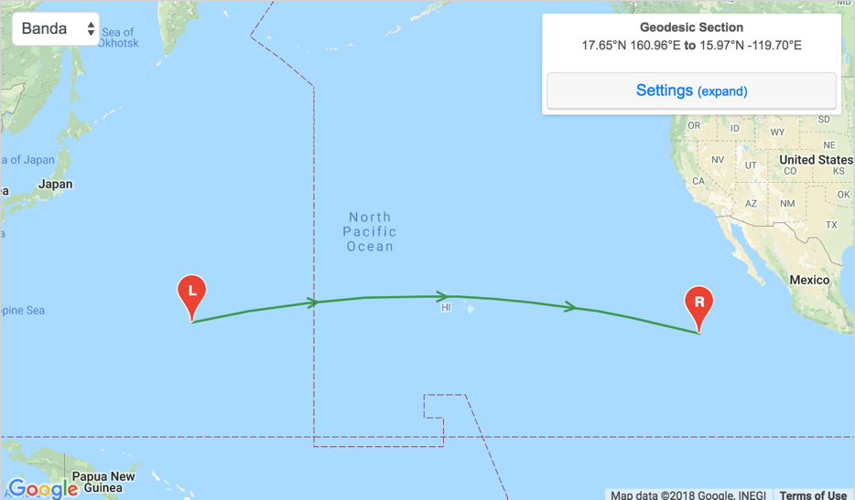

Figure – Example of the line needed for questions 7 and 8.

1. Observe the tomographic section under Hawaii. What can we conclude about the seismic velocity of the mantle under Hawaii? Is it faster, or slower than expected? What else can you observe?

1. Which of the plate boundaries (i.e., convergent or divergent) that we have looked at thus far most resembles the mantle under Hawaii? Explain.

Next, move the “L” and “R” markers to rotate your cross-section around Hawaii, always maintaining Hawaii at the cross-section center. Some examples are shown below. Look at 3 to 4 different cross-sections around Hawaii.

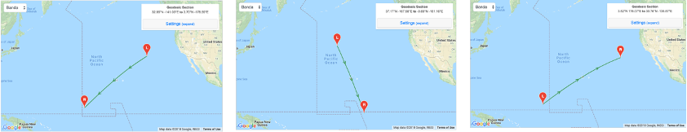

Figure - Example map needed for question 9

1. Examine the mantle feature below Hawaii. Describe in your own words which 3D shape (i.e., cube, sphere, circular column, etc.) might best describe the observed mantle feature under Hawaii. Which features from Figure 1 can you identify in your tomographic cross-section? Explain.

# Part 4: Divergent Plate Boundaries

As shown on Figure 7 on the Google Maps interface, move the “L” marker to the coastal Newfoundland in the Labrador Sea. Move the “R” marker to the southern tip of Ireland. 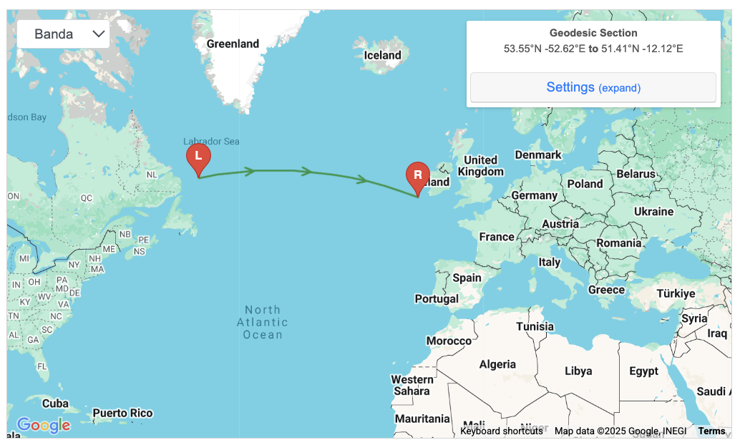

Figure – Example map needed for Part 4.

1. What major ocean is at the top surface of our cross-section?

1. Your cross-section cuts across a mid-ocean spreading ridge and a major divergent plate boundary. Describe in your own words what you observe from tomography of the Earth’s mantle under this major ocean. State the depth of at least one feature in km. Which features from Figure 1 (on page 2) can you identify in your tomographic cross-section? Explain.

# Part Five: Feedback

1. To help the design of this assignment for future classes, please provide feedback on this assignment.
   1. Which part of the assignment was most helpful or interesting?

* 1. Which part of the assignment was unclear or confusing?

## Assignment Submission

All virtual field trips are due by Sunday, April 27. Save your completed Word document as “yourlastname_firstname_MantleVFT”. Failure to use this naming convention may result in you not receiving credit. The file size must be less than 10 MB. If you need to [reduce your file size](https://support.microsoft.com/en-us/office/reduce-the-file-size-of-your-word-documents-6c5a1186-6353-453d-bb22-e9322c2cfbab), make sure images/annotations are still legible. Submit your completed document using the following [form](https://forms.office.com/r/ev94un4pJe), you must be logged into your @cougarnet.uh.edu Microsoft account. Only Microsoft Word and PDF formats are accepted.

**Due Date:** Sunday, April 27

**Submission link:** <https://forms.office.com/r/ev94un4pJe> (make a separate submission for each VFT you complete)

Teaching Assistants will begin grading submissions after the deadline. After your work is graded, you will receive a confirmation email from a TA. Submissions are graded as pass/fail. If your assignment requires resubmission because of too many incorrect questions, missing answers, or incomplete sentences, you will have 48 hours to do so.



The National Science Foundation is thanked for providing

funding and support to develop this educational curriculum (Grant EAR-1848327). The exercise was developed by Dr. Jonny Wu and Spencer Fuston at the University of Houston. Dr. Jinny Sisson provided helpful comments and review.