## **Extending the Life of Offshore Oil and Gas Infrastructure in the Gulf of Mexico for Profitable New Uses in Power and Hydrogen Generation in Preparation for the Energy Transition**

Principal Investigator: Dr. Ram Seetharam

**Summary**

The Gulf of Mexico is home to around 1500 oil and gas structures (Figure 1) that have either reached or are approaching the end of their oil and gas production lifespan. These structures will require decommissioning in the coming decades. UH Energy launched a research program called ROICE (Repurposing Offshore Infrastructure for Clean Energy) in the Fall of 2021 to assess the techno-economic feasibility of repurposing these structures to generate clean energy. The ROICE cases modeled in these phases envision the installation of wind turbines around an idle structure. The generated power is transmitted to shore or used to produce green hydrogen. The existing platform jacket and topsides are repurposed to accommodate new topsides for power generation or hydrogen generation.

Figure 1 Oil and Gas Infrastructure in the Gulf of Mexico

An advisory team called the ROICE Program Collaborative (RPC, Figure 2) was assembled, made up of over 40 organizations and companies including equipment manufacturers, technical consultants, national labs, and engineering companies. Members of the RPC provided critically needed consultation, technical oversight, and input data to the program (Figure 3).



Figure 2 ROICE Project Collaborative (RPC) – Advisory Group

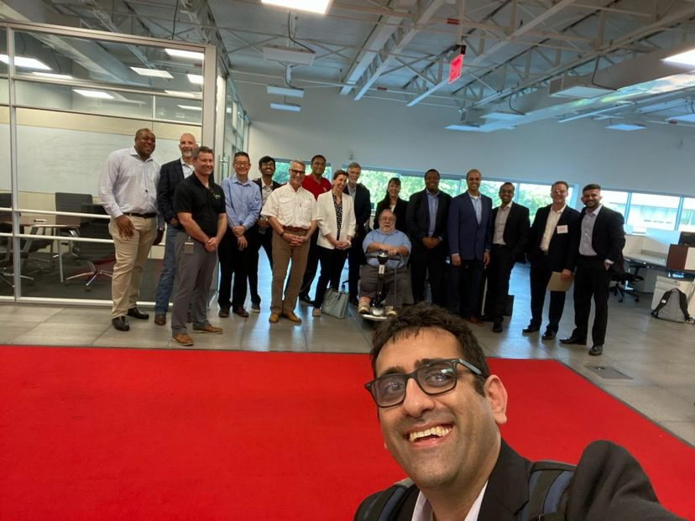

Figure 3 Members of the RPC at a ROICE Workshop April 2023

Funding for Phases 1 and 2 of this program was obtained from TCEQ/RESTORE Act in Spring of 2022 enabling the formation of the ROICE research team (Figure 4), headed up by Dr. Ram Seetharam (PI). The team includes UH students Paulo Liu, Ph.D. candidate in Petroleum Engineering, Muhammad Younas, Ph.D. student in Geophysics and Yug Patel, a senior in the Physics Honors Program.

Figure 4 THE ROICE Research Team (Top: Yug Patel, Ram Seetharam; Bottom: Paulo Liu, Muhammad Younas)

Phase 1 was completed in August of 2023 with the development of a ROICE Levelized Cost (LC) Model and LC maps for the Gulf of Mexico examining the potential for such repurposing projects. Results of Phase 1 were presented at the 2024 Offshore Technology Conference (Figure 5). In addition, two papers have been submitted to *Renewable and Sustainable Energy Reviews* journal.

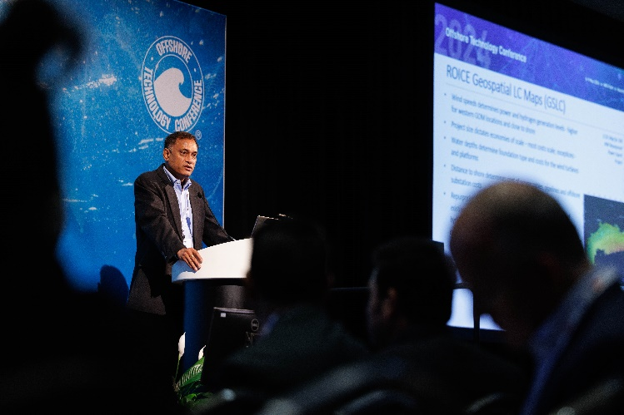

Figure 5 Results of Phase 1 being presented at the

2024 Offshore Technology Conference by Dr. Seetharam

Phase 2 is expected to be completed by August 2024 with the development of high level designs for placement of power and hydrogen modules on typical GOM platforms, and a comprehensive ROICE economic model. The path to profitability of power and hydrogen ROICE projects will be examined in detail and recommendations will be made in the final report on how to make such projects attractive to commercial investors.

The 2024 ROICE Workshop was recently held on June 20th. Results of Phase 2 were reviewed with the RPC and their input was sought to develop plans for Phase 3 of the program. This Phase 3 work scope will partially be funded by a recent two-year, $750K grant awarded to the program by DOE’s NETL office. Additional funding to cover the remaining Phase 3 scope if being sought from federal and state agencies.

Figure 6 Promethean Energy and Endeavor Management signed MOU’s with UH Energy and the ROICE Program at the 2024 Workshop

At this workshop, two of the RPC members – Promethean Energy and Endeavor Management – signed MOU’s (Figure 6) to cooperate with UH Energy and support the ROICE program. support was given to moving forward with planning for a small scale ROICE demonstration project in the GOM. Such a project would serve as a test bed for different technologies, design and execution of ROICE projects and tests on ways to improve the profitability of such projects. Among other things, Phase 3 work scope will include defining the scope for such a demonstration project, preliminary design and project execution plans.

*The funding received from TCEQ for Phases 1 and 2 has thus resulted in multiple presentations and technical papers on repurposing fossil fuel assets, generated funding for additional research, enabled the formation of a strong advisory group and catalyzed plans for a demonstration project.*

**Research Deliverables and Results**

The ROICE LC model (Figure 7) includes equipment such as turbines, cables, substations, electrolyzers, pipelines, and structures. It can estimate LC for ROICE project - repurposing an existing offshore oil and gas platform to generate wind power or hydrogen – at any location in the GOM. The concept of LCOE provides a way to compare costs across different pathways of energy generation on a common basis.

Figure 7 ROICE LC Model

The LC model for such ROICE projects was then used to create Geospatial Levelized Costs (GSLC) maps for the GOM and estimate LC for all asset locations. An example GSLC Map for a 435 MW ROICE Power Export Project (Figure 8) and a 105 MW ROICE Hydrogen Export Project (Figure 9) are provided here.

Figure 8 Levelized Cost map for GOM locations for a 435 MW Wind Power Export Project

Figure 9 Levelized Cost map for GOM locations for a 105 MW Hydrogen Export Project

Such GSLC maps were used to examine trends and to identify challenges and opportunities for profitable ROICE projects. LC is a complicated function that depends on several variables, including wind speed, ocean depth, distance to shore, project size, and the decision between constructing a new build versus repurposing. The resulting LC, without federal or state incentives or assumptions about cost reductions and technology advancements, were found to be higher than onshore renewables, and they face even greater challenges compared to high-carbon alternatives. Nevertheless, projects in the lower range of LC in the GOM region can compete through efficient design, cost reductions, and utilizing federal and state incentives. Repurposing can reduce LC by 5 to 10% for projects in shallow water, and 25% to 60% for deeper water projects.

Phase 2 is expected to be completed by August 2024. In this phase, ROICE topsides designs were developed using information on power systems, electrolyzers and desalination modules. The placement of these modules on typical Gulf of Mexico platforms was investigated. All available deck space was utilized to generate estimates of project size for typical 8, 12 and 16-leg platforms. Hydrogen projects were found to be limited to 100 MW or less, while power projects could be as large as 500 MW. Figure 10 shows such a placement exercise for a 16-pile platform in the GOM, resulting in a 100 MW hydrogen export project.

Figure 10: 100 MW Electrolyzer Units and Other Equipment on Main Deck of a Typical 16-Pile Platform in the West Delta Area (Green: Electrolyzer, Blue: Cooling Unit, Yellow: Oxygen/Water Separation Unit, Gray: Hydrogen Chiller, Cyan: Hydrogen Dryer, Magenta: Circulation Pumps)

Also, as part of Phase 2, a detailed economic model for ROICE projects was also built including federal incentives, loan financing, power and hydrogen generation models, offtake pricing and capex reduction scenarios. The path to profitability of power and hydrogen ROICE projects was examined in detail by looking into over 100 cases with different capex assumptions, offtake pricing assumptions and borrowing costs. Recommendations will be made in the final report on how to make such projects attractive to commercial investors.

Results of this economic analysis for ROICE wind power export projects are shown in Figure 11. These cases assume a 50% reduction in CAPEX outlay – either through federal incentive programs, or through technology and supply chain improvements. As can be seen, such a significant CAPEX outlay reduction is needed for these projects to be profitable. Alternately, higher offtake pricing – either through federal subsidies or through customers willing to pay a green premium – could also make these projects profitable.

Figure 11 ROICE Economic Model Results for Power Export Cases with 50% CAPEX reduction from 2023 Estimates

**Conclusions and Future Study**

 In Phase 1 of this research study, the ROICE LC model has been used to generate the GSLC maps that show LC distributions for different project scenarios across the GOM. These scenarios include new builds and repurposed versions of wind and hydrogen projects at both demonstration and commercial scales. The maps were used to estimate screening level LC values for each of the ~1500 assets in the GOM to identify favorable locations for different versions of ROICE projects.  Key Phase 1 conclusions are listed below.

* The LC for repurposed wind projects in the Gulf of Mexico varies between $82 and $231 per megawatt-hour (MWh). New build projects of comparable scope have a range of LC between $82 (MWh) and $437 (MWh).
* The LC for repurposed hydrogen projects in the GOM ranges from $4.76 to $8.44 per kilogram (kg) of hydrogen. The LC of equivalent new build projects varies between $4.77 and $19.64 per kg.
* It should be noted that the aforementioned LC does not take into account any federal or state incentives. However, they still have higher costs compared to onshore projects that rely on low-carbon renewables. Additionally, these LC projects face even greater difficulties when compared to high-carbon alternatives.
* Nevertheless, projects with lower levels of LC in the GOM region have the ability to compete with onshore projects by employing efficient design, cost-cutting measures, and taking advantage of all applicable federal and state incentives.
* Repurposing has the dual effect of reducing CAPEX and shortening the implementation timeline of ROICE projects. Most projects will experience a favorable influence on their LC through repurposing. The improvement is particularly noticeable in projects involving deeper water and smaller-scale projects when the cost reductions resulting from the reuse of infrastructure make up a substantial component of the overall project CAPEX.

In Phase 2 of this program, the ROICE Cost Estimator model has been refined and a detailed ROICE Economic Model has been built. Hydrogen and power module placement exercise has been carried out for several typical offshore deck layouts. Project economics have been estimated for a range of project sizes, offtake prices, capex reduction, loan rates and other scenarios.

While Phase 2 work is still ongoing, a few key conclusions are listed below.

* ROICE projects can cover the cost of decommissioning. Pre-ROICE Decommissioning costs, being only ~10% of ROICE project capex for small projects and 1 to 3% for larger projects, can be added to the project CAPEX without significant impact on economics. The cash flow from ROICE projects more than sufficient to cover pre- and post-ROICE decommissioning
* Challenge is in generating an acceptable rate of return on ROICE capex. All projects – power, H2, varying sizes challenged at today’s capex. Borrowing costs have a major impact on project profitability – low-cost loans needed
* Keys to profitability of ROICE projects
  + Scale: hydrogen topsides footprint limits max project size to ~ 100 MW; power projects less limited – can be as large as 500 MW
  + Green Premiums / Offtake Incentives: 2 to 5 cents of additional PTC incentives needed for power; 2 to 5 $/kg additional 45V incentives needed for hydrogen
  + Capex Reductions / Additional Investment Incentives: 50% reduction needed from 2023 capex; through design and technology improvements, supply chain resolution, tax incentives etc.
  + Low-Cost Loans: Low cost loans from foundations and federal agencies are needed to catalyze the offshore clean energy sector, and repurposing of offshore assets.

**Publications**

Patel Y, Younas M, Liu P, Seetharam R. Repurposing Offshore Infrastructure for Clean Energy (ROICE) vs. Decommissioning–Techno-Economic Considerations. In Offshore Technology Conference (April, 2024), (p. D031S040R005). OTC.

Patel Y, Younas M, Liu P, Seetharam R. Levelized cost model for repurposing oil and gas infrastructure for clean energy projects in the Gulf of Mexico, United States (submitted to *Renewable and Sustainable Energy Reviews* journal)

Younas M, Patel Y, Liu P, Seetharam R. Challenges and opportunities for repurposing offshore oil and gas infrastructure for clean energy in the Gulf of Mexico, United States (submitted to *Renewable and Sustainable Energy Reviews* journal)